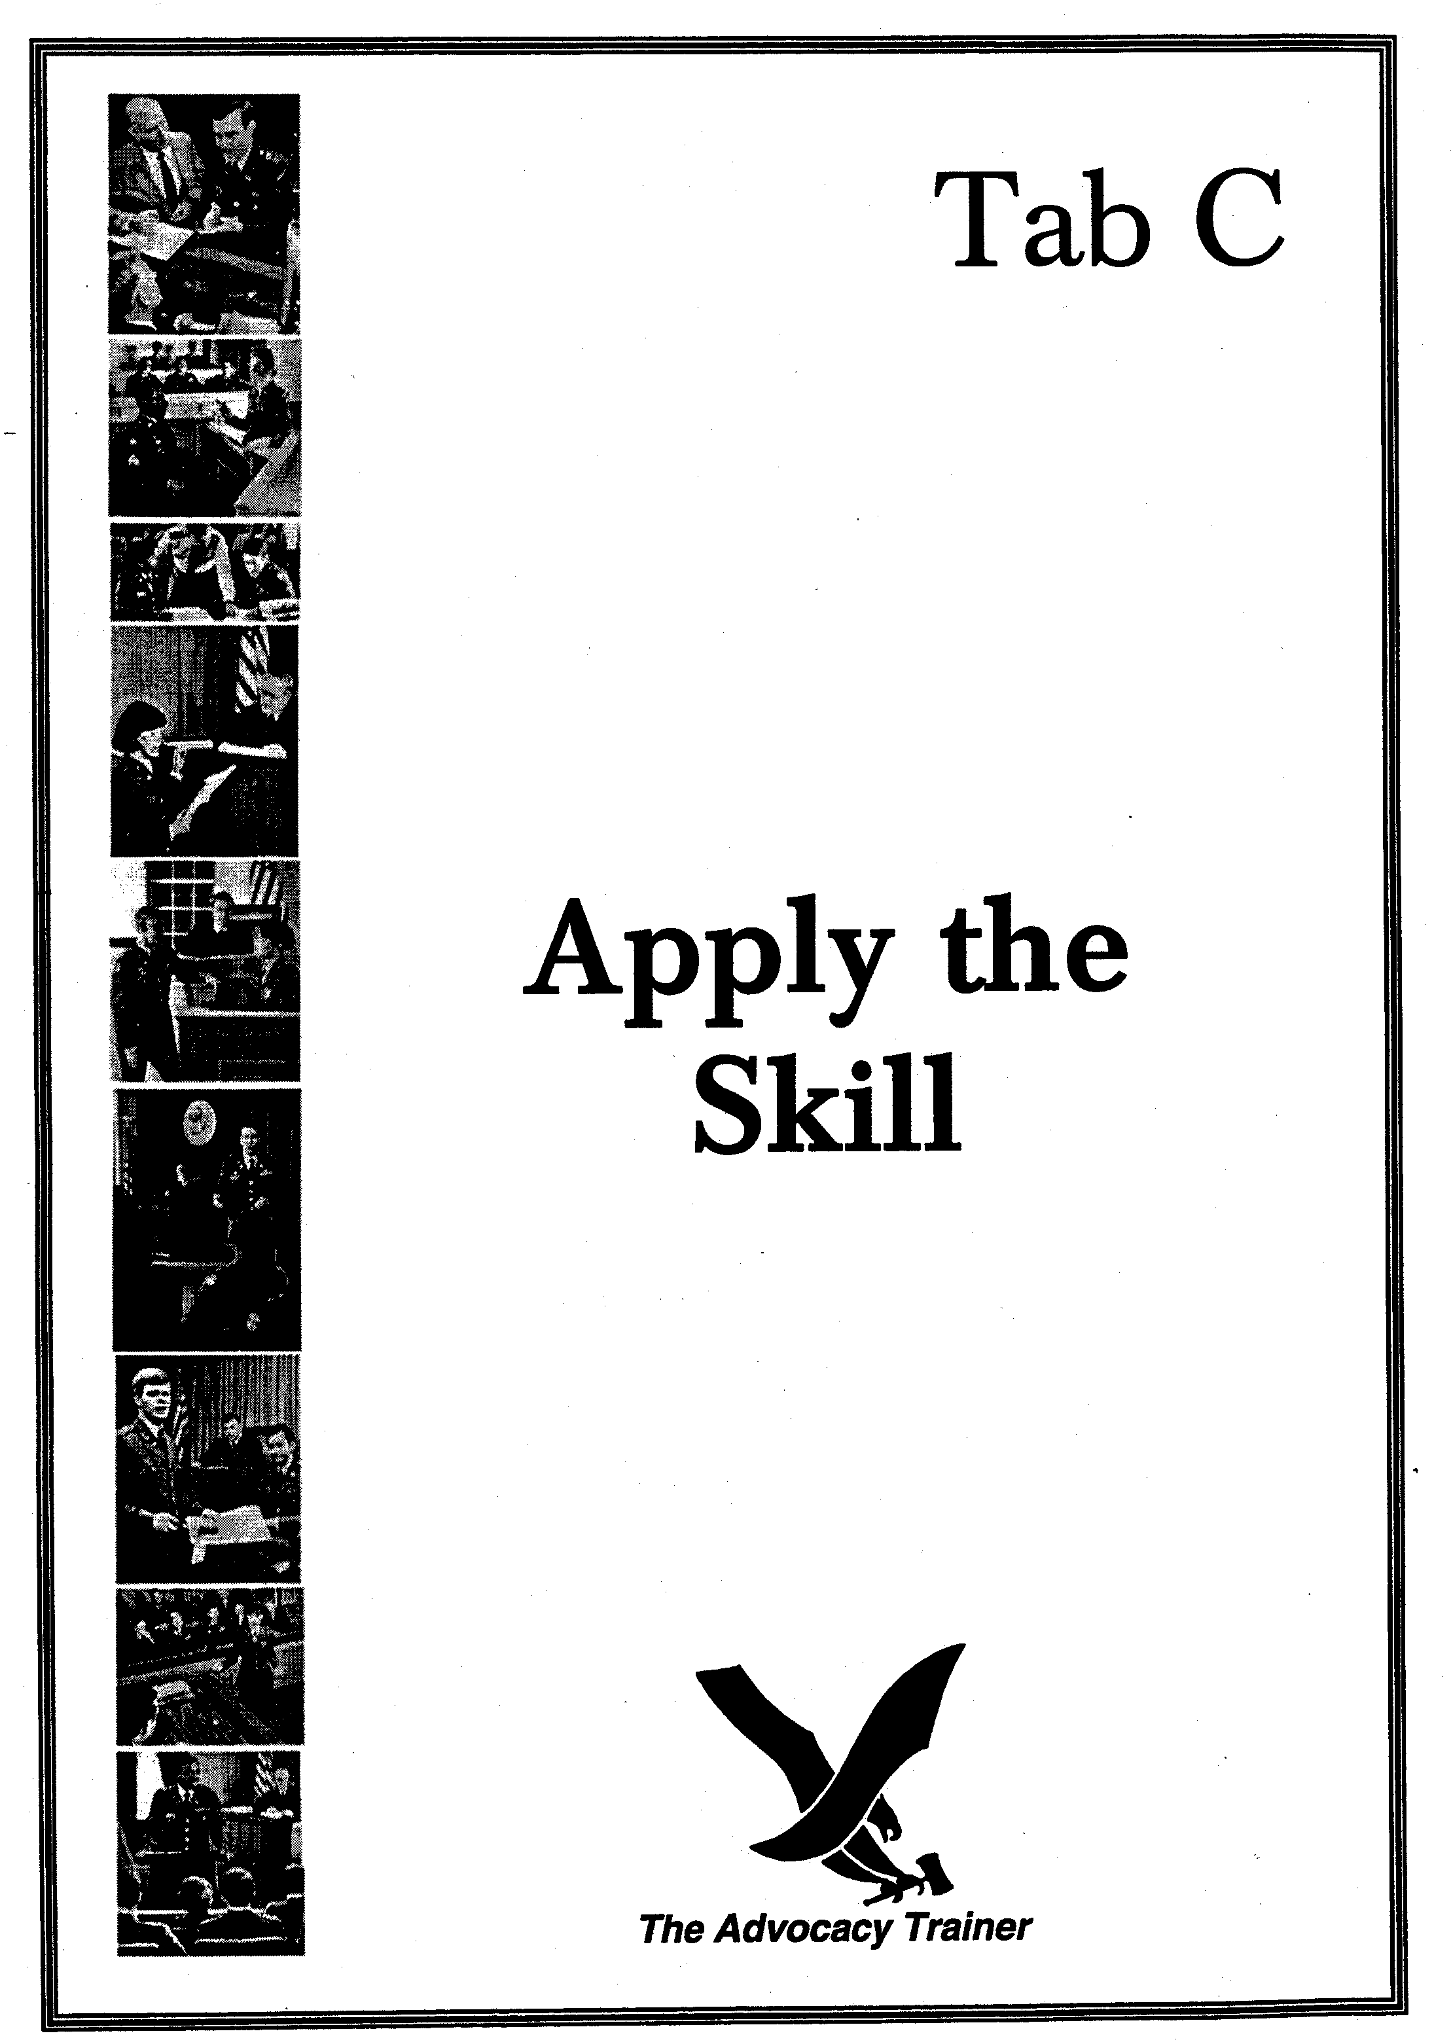
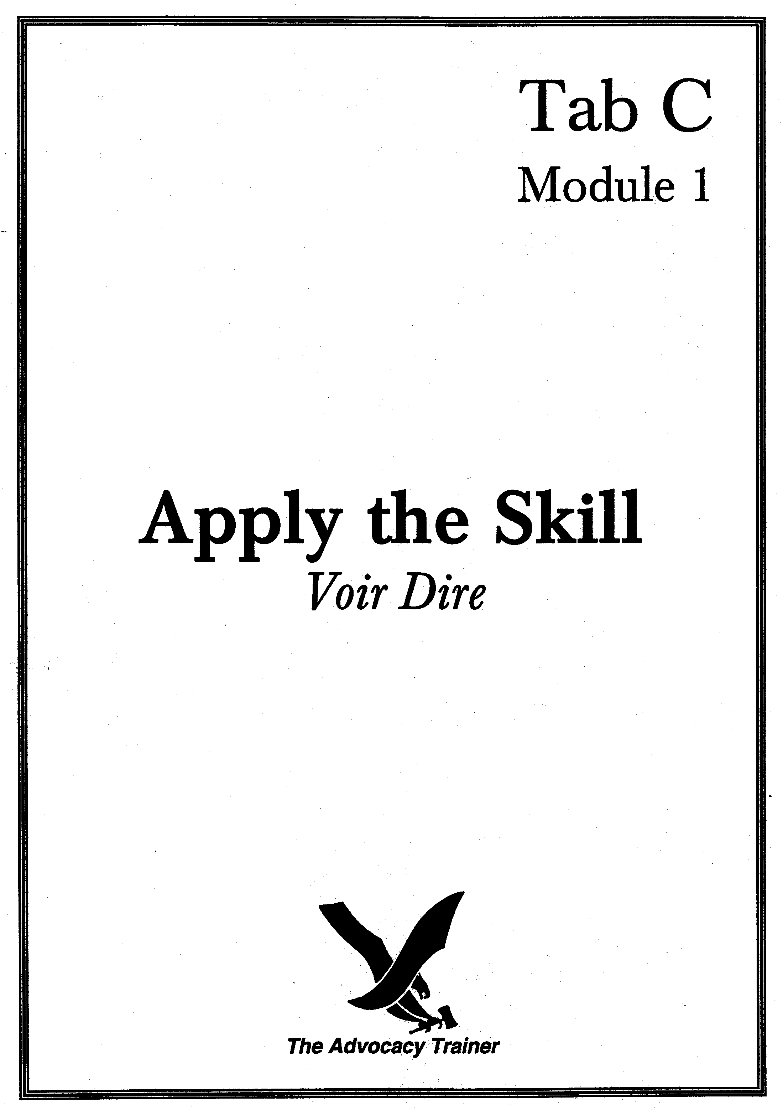
voir dire
supervisor’s guide

 skill overview.

Goals. The goal of this section is to develop counsel’s confidence and ability to prepare and execute general and individual voir dire through careful preparation, relevant questions, and judicious assertion of challenges.

Training Overview. This training has six separate drills. The training requires two to five participants. The training is divided into four steps: (1) a short period of instruction; (2) counsel preparation; (3) practical exercises and critique; and (4) a review of the sample solutions. There is one fact scenario which counsel can use to develop voir dire questions. Alternatively, counsel can use pending cases for additional fact scenarios. It should take no more than two hours to instruct, prepare and perform each drill.

 the law.
- “Before trial the trial counsel may, and shall upon request of the defense counsel, submit to each member a written questionnaire requesting certain basic information [and] additional information may be requested with the approval of the military judge." R.C.M. 912(a)(1).
- “The use of questionnaires before trial may expedite voir dire and permit more informed exercise of challenges.” Discussion R.C.M. 912(a)(1).
- “In addition to member questionnaires, a copy of any written materials considered by the convening authority in selecting members will be provided to any party upon request.” R.C.M. 912(a)(2).
- “Before voir dire of members, any party may move to stay the proceedings on the ground that members were improperly selected.” R.C.M. 912(b)(1).
- “The military judge may permit the parties to conduct the examination of members or may personally conduct the examination. In the latter event the military judge shall permit the parties to supplement the examination by such further inquiry as the military judge deems proper or the military judge shall submit to the members such additional questions by the parties as the military judge deems proper. A member may be questioned outside the presence of another member when the military judge so directs.” R.C.M. 912(d).
- “The opportunity for voir dire should be used to obtain information for the intelligent exercise of challenges.” R.C.M. 912(d), Discussion.
- “Any party may present evidence relating to whether grounds for challenge exist against a member.” R.C.M. 912(e).
- “Each party may challenge one member peremptorily.” R.C.M. 912(g).

 the art.

The Canvas. There are three primary goals of voir dire. First, ascertain any prejudice, bias, or experiences that would prevent a panel member from being fair and impartial. For example, a potential panel member who had been the victim of the same or similar crime. Second, educate the panel on the theory of your case. This includes educating the panel on any legal principles that are important to your case. Third, establish rapport with the panel. Voir dire is the first interaction with the panel and opportunity to impress them with your command of the case. The principles discussed below will assist in developing a good voir dire presentation.

The Strategy.
- Be Prepared. R.C.M. 912(a)(1) allows panel members to complete questionnaires before trial. R.C.M. 912(a)(2) allows both parties to review all written matter considered by the convening authority to select panel members. These documents contain valuable information on prospective panel members.
- Always review questionnaires, ORBs, and the 2A/2-1s of prospective panel members. These documents will prompt narrowly tailored questions, give counsel a better picture of the panel, and prevent counsel from asking repetitive questions.
- Sit in on other trials to observe counsel and members in the voir dire process.
- If a standing panel is used, ask counsel who have tried cases before the same panel about the panel members.
- Determine the areas you need to explore. Write out your questions and rehearse. Ask yourself, what is the purpose of the question? Is the question clear and easy to understand?
- Practice by asking someone who doesn’t know the case to listen to your questions.
- Prepare a Case Specific Questionnaire. The use of tailored questionnaires may expedite voir dire and assist counsel in developing challenges for cause.
- Draft a case specific questionnaire early in your case.
- Use open-ended questions in the questionnaire.
- Review questionnaires that have been used by other counsel.
- Negotiate potentially objectionable questions with opposing counsel.
- Seek the military judge’s approval to use the questionnaire.
- Prepare a motion to litigate for the questionnaire that you want.
- Questionnaires provide members an opportunity to answer questions without embarrassment in court.
- Tactically, questionnaires allow counsel to pose questions without the member knowing which party is seeking the information.
- Know the Law. The stated purpose of voir dire under R.C.M. 912(d) is to obtain information for the intelligent exercise of challenges.
- Counsel must be familiar with the 14 bases for disqualification under R.C.M. 912(f). They are:
- Member does not meet the qualifications of Article 25(a), (b), or (c).
- Member not properly detailed
- Member is an accuser to any offense charged
- Member will be a witness
- Member has acted as counsel for any party as to any offense charged
- Member has been an investigating officer to any of the offenses
- Member has acted as the convening authority or legal advisor on the case
- Member will act as the reviewing authority or legal advisor on the case
- Member has forwarded any of the charges with a personal recommendation as to disposition
- Member sat on the original case if this is a re-hearing , new, or other trial of the case
- Member is junior to the accused, unless it couldn’t be avoided
- Member is in arrest or confinement
- Member has formed or expressed a definite opinion on the guilt or innocence of the accused as to any charged offense
- Member should not sit in order to keep the court-martial free from substantial doubt as to legality, fairness, and impartiality.
Examples include: member has a direct personal interest in the result of the trial; is closely related to the accused, a counsel, or a witness; has participated as a member or counsel in the trial of a closely related case; has a decidedly friendly or hostile attitude toward a party; or has an inelastic opinion concerning an appropriate sentence for the offenses charged.
- Counsel must fully develop any perceived bias to form a factual basis for later challenges.
- Put a member’s nonverbal actions and expressions on the record. (e.g. "Major X looked down and was shaking his head from side to side").
- Counsel should try to rehabilitate panel members and, if possible, object to any challenges for cause.
- Remember that the military judge should liberally grant challenges for cause.
- Exercise of a peremptory challenge requires special attention when used against a member you unsuccessfully challenged for cause. The “But For” rule under R.C.M. 912(f)(4) requires you to tell the military judge, "but for your denial of my challenge for cause against member X, I would have used my peremptory challenge against member Y." If you do not exercise a peremptory challenge against member X, and state that you would have used it on another member, you waive any objection to the denied causal challenge.
- Know Batson Requirements. Counsel may not exercise their peremptory challenge in a discriminatory manner (based on race or gender). The prohibitions apply to both parties. Further, the accused and the challenged panel member do not need to be of the same racial group. For example, the trial counsel must articulate a gender-neutral reason to peremptorily challenge the only female member from the panel.
- Before exercising a peremptory challenge on a minority member, counsel must articulate race or gender neutral reasons that are unambiguous and supported by the record.
- Be prepared to articulate as many race neutral reasons as possible in order to protect the record.
- Opposing counsel must force the challenging party to specify a race or gender neutral reason for the challenge in order to preserve the issue.
- Know your Judge. The nature and scope of voir dire is within the discretion of the military judge. R.C.M. 912(d).
- The judge will likely ask several preliminary questions similar to the questions set out in the Military Judge's Bench Book (pages 41-54). Listen to the member's responses to these questions. Don’t repeat those questions. However, if you need to explore these areas, ask additional questions.
- Some judges may require counsel to submit proposed questions in writing. If so, have questions and a rationale for the questions ready.
- No two judges conduct voir dire the same way. It is important to find out what kind of questions the judge typically allows. Controversial questions should be cleared with the judge beforehand, i.e., questions concerning burdens of proof, defenses, or elements of an offense.
- Know the Case. Counsel must know their case thoroughly before they can educate panel members on their theory. This includes the strengths and weaknesses of both sides.
- Counsel should select the most critical portions of the case on which to question panel members. For example, if the trial counsel plans to prove the case using testimony from an accomplice, question the panel to ensure that each member can convict the accused based on accomplice testimony. Likewise, in a self-defense case the defense counsel must ensure that panel members agree that there are situations where people are justified in using force.
- Weave the theory and theme of the case into the questions.
- Highlight the weaknesses of the opponent’s case.
- General Questioning Techniques. Voir dire is your first opportunity to make a good impression on the members. How you conduct yourself can either enhance or diminish your credibility.
- Know your questions. Avoid looking down at your notes. Make eye contact with the members while asking questions.
- Listen to and observe the verbal and non-verbal responses of panel members. Watch for changes in facial expressions, body movements, avoidance of eye contact, hesitancy to respond, and other indications that a member is uncomfortable or insincere in his or her response. Make a note of these so that you can use them to support a challenge for cause.
- Ask panel members to signify their responses in an unequivocal manner. For example, “Raise your hand if you agree that . . .”
- Direct your questions to every panel member, not just the president.
- Ask questions in a conversational tone.
- Use simple language; avoid legalese.
- Don’t ask repetitive or unnecessary questions. Every question must be directly tied to one or more of the purposes of voir dire.
- Don’t taint the entire panel with follow-up questions. For example, if a member says he has knowledge of the case or knows a witness, do not ask what he has heard or what he thinks of a witness. Ask follow-up questions in individual voir dire.
- Don’t ask trick questions. Such questions only serve to alienate members and cause them to distrust you.
- Educate members on the law by relating questions to the judge’s instructions. For example, “If the Military Judge instructs you that the defense of accident is a complete defense to the charge, raise your hand if you can follow that instruction?”
- Don’t misquote or misstate the law. If you do, you will lose credibility. Consider having the judge provide an instruction during voir dire in an area that you want to explore.
- Open-Ended v. Leading Questions. It depends on the purpose of the question whether open-ended or leading questions are appropriate. For example, trial counsel may ask leading questions regarding sentencing philosophies to preempt defense counsel’s open-ended questions on the same subject.
- Use leading questions to educate the panel on legal and factual concepts. (e.g. LTC X, wouldn't you agree that an accused has a right to remain silent?).
- Ask open-ended questions to expose potential bias. Open-ended questions let members answer questions using their own vocabulary and manner of expression. This gives counsel a better insight into the member's opinions. (e.g. Major Y, what thoughts enter your mind when you learn that a suspect exercised his right to remain silent when questioned about a particular crime?").
- Keep Track of Answers and Follow-up. Counsel must have a method for accurately recording responses, particularly during group voir dire.
- The best method is to draw up a matrix and have co-counsel carefully record all responses from both parties and the military judge. Use some type of shorthand and key so that you can quickly record answers and decipher what you are writing.
- If there is no co-counsel, a matrix and seating chart is vital. Consider asking a co-worker to sit in the gallery and take notes for you.
- Record not just what the member said, but how he or she said it.
- Carefully record responses that may be the basis for a causal challenge.
- Areas of Focus for Trial Counsel. Trial counsel should be particularly aware of the following areas:
- Unusual or complicated theories such as conspiracy, attempt, accessory after the fact, principal, etc.
- Immunized witnesses, confidential informants, and accomplice testimony.
- Circumstantial evidence and other scientific evidence such as urinalysis results, BAC results, DNA evidence, etc.
- Credibility of child witnesses or victims of date rape.
- Unsympathetic victims.
- Police misconduct and command shortcomings.
- "Victimless" crimes.
- Vicarious liability.
- Areas of Focus for Defense Counsel. Defense counsel should be particularly aware of the following areas:
- Experience of the members or their family members with the offenses charged.
- Explanation of relevant defenses such as self defense, entrapment, alibi, etc.
- Witnesses testifying under immunity.
- Whether the accused will testify.
- Individual attitudes toward CID, alcohol, drugs, DNA, child witnesses, or other key aspects of the case.
- Developing a Challenge for Cause. In developing a challenge for cause, counsel should be intimately familiar with the grounds for a challenge for cause and the members' responses to the questionnaires. In addition, counsel need to be aware of the following techniques in setting up a challenge for cause.
- Never use questions that are accusatory, reproaching or cause embarrassment.
- Counsel should always begin looking for potential challenges for cause by reviewing the member questionnaires and then probe a little deeper with the use of non-leading and open-ended questions in general voir dire.
- During general voir dire counsel should avoid going into detail with a member on an issue that might ripen into a challenge for cause so that the other members are not tainted by the member’s response.
- If a member’s response in general voir dire clearly establishes a ground for a challenge for cause, then counsel should ask the other members if they agree with the member’s response. If other members agree, then the number of members that could be challenged for cause has increased. These members should be queried further on individual voir dire.
- In individual voir dire, counsel should shift to the use of leading and close-ended questions.
- One potential source of challenges that counsel should pursue is whether any members have had any previous contact with counsel, witnesses, or the accused. Based upon these prior contacts, the member may have either favorable or unfavorable opinions that can affect their ability to be fair and neutral.
- Another potential source for a challenge for cause is the possibility that the members have heard something about the facts of the case. Just because a member may have heard something about the case does not disqualify the member per se. Instead, counsel need to focus on whether the member can set aside what they heard and make their decision solely on the evidence presented in court. In this regard, counsel needs to get the member to state on the record “how” they would be able to set aside what they heard earlier.
- Where a member, or a family member or friend has been accused or convicted of a crime, or was the victim of a crime, counsel need to inquire into this area in individual voir dire. Again, counsel should not merely accept the member’s assurances that they can set aside these facts and faithfully execute their duty as a member. Counsel should seek to have the member explain “how” he would do so. If a challenge for cause is denied in this area, counsel should generally exercise a peremptory challenge.
- Counsel should attempt to discover if any member has been influenced by the acts or words of the officer convening the court. Counsel needs to inquire whether the convening authority, or any other senior military authority, has commented on the case to a member personally or in their presence. If comments have been made, counsel needs to establish what was said and the situation in which it was said.

 the skill drills.

Goal: Train counsel to use the following skills.

Prepare case-specific questionnaires.

Prepare case-specific voir dire questions.

Conduct a group and individual voir dire session with the specific purpose of establishing a basis for a challenge for cause.

State grounds for appropriate challenges for cause and then any peremptory challenges, if desired.

Conduct the drills.

Preparation: There are six drills. This training module requires two to five participants, depending on the specific drill used. A fact scenario involving conspiracy and rape serves as the vehicle for the training. You can use pending cases for additional fact scenarios. The training is divided into four steps: (1) a period of instruction; (2) counsel preparation time; (3) a practical exercise and critique; and (4) a review of the sample solution. It takes approximately two hours to complete each drill. Decide which skill drills to conduct based upon time, resources, and experience level. One approach is to proceed in order from skill drill # 1 through skill drill #6.

Drill #1: This drill requires at least three people: the supervisor and two counsel.

Step 1. Prepare a 15-minute period of instruction on the elements of preparing a tailored questionnaire and how to use it in conducting voir dire.

Step 2. At the end of the instruction, give counsel the enclosed fact scenario and assign them roles as either trial or defense counsel. Counsel will then spend 30 minutes drafting a tailored member questionnaire based on the facts of the scenario.

Step 3. Supervisor will play the role of the military judge and listen to counsel’s arguments for and against the use of the tailored questionnaire.

Step 4. Critique and go over the sample questionnaire.

Drill #2: This skill drill requires at least three people: the supervisor, one counsel, and a panel member. This drill can be used as an extension of the first drill. If not, conduct steps 1 and 2 above. If possible, select non-lawyers as mock panel members. Have the members complete the questionnaire and then distribute the responses to counsel. Then have counsel conduct voir dire on members of the mock panel based upon the members’ responses on the tailored questionnaire. During this drill, counsel will test the veracity of a member’s responses on the questionnaire. For example, if a member refuses to answer specific questions on the questionnaire, counsel must explore why. Counsel will then be critiqued by the members and the supervisor and will go over sample lines of questioning.

Step 1: Using the Supervisor’s Guide for this training, present a 15 minute period of instruction on the elements of preparing and conducting voir dire.

Step 2: At the end of the instruction, give counsel the enclosed conspiracy/rape fact scenario. Assign counsel the role of either trial counsel or defense counsel. Counsel will prepare general voir dire questions based on the fact scenario. Specific areas of focus are accomplice testimony, conspiracy, grants of immunity, and inconsistent statements of potential witnesses. Give counsel 30-45 minutes to prepare.

Step 3: Once preparation is complete, have counsel ask questions of the panel members. Conduct this portion of the training in a location free from interruptions. Critique counsel’s performance. The questioning should last about 20 minutes.

Step 4: After the exercise, distribute the appropriate sample solution to counsel. Review and discuss the solutions with counsel. The review should last 15-30 minutes.

Drill #3: This drill will require at least two people: the supervisor and one counsel.

Step 1. Prepare a 15-minute period of instruction on the elements of preparing a challenge for cause.

Step 2. At the end of the instruction, give counsel the enclosed fact scenario and tailored questionnaires. Counsel will then make a list of potential areas ripe for developing challenges for cause.

Step 3. The supervisor will assume the role of a member and have counsel attempt to establish a challenge for cause.

Step 4. At the end of this drill, the supervisor will critique counsel and provide them with a sample answer.

Drill #4: This drill is a variation of the previous skill drill. Rather than just questioning the supervisor, get several non-lawyers to listen to counsel's questions to see if they understand what information counsel are seeking. Follow the steps outlined in skill drills #2 and #3. If you have already conducted the basic instruction, there is no need to repeat these steps. Consider doing this skill drill as a follow-up to the prior exercises. The supervisor may want to give counsel more time to polish questions they developed in the first exercise.

Drill #5: This drill requires five people: the supervisor, the counsel, and three mock panel members (preferably non-lawyers of different ranks). This drill requires counsel to develop general voir dire questions. This drill also gives counsel the opportunity to craft follow-up questions and practice presentation techniques.

Step 1: Using the Supervisor’s Guide for this training, present a 20-30 minute period of instruction on the elements of preparing and conducting voir dire. Focus particularly on questioning techniques. There is no need to repeat this step if you conducted this training in the previous drills.

Step 2: At the end of the instruction, give counsel the enclosed conspiracy/rape fact scenario, court member packets, and seating chart enclosed. Assign counsel the role of either trial counsel or defense counsel. Counsel will prepare voir dire questions based on the fact scenario and the court member packets. Give counsel as much time as necessary to prepare. One approach is to conduct Step 1 the first week and then give counsel a week to prepare questions. Prior to the training select soldiers (preferably non-lawyers) to serve as mock panel members. Give each panel member one of the enclosed member packets containing personnel records, the court member questionnaire, and biography of that member. Advise mock panel members not to discuss the information contained in the packet prior to the training exercise.

Step 3: Once preparation is complete, have counsel conduct group voir dire of the mock panel. Conduct this portion of the training in the courtroom or other location free of interruptions. Critique counsel’s performance. Get input from mock panel members to see if they liked counsel's style and understood the questions.

Step 4: After the exercise, distribute the voir dire checklist to counsel as a sample solution. Review and discuss possible solutions with counsel. The review should last 30-45 minutes.

Drill #6: This drill can be an extension of Drill #5. After the first two steps in Drill #5, divide counsel up into trial counsel and defense counsel. Then have counsel prepare voir dire of at least three members with the goal of getting one or more of them challenged for cause. The supervisor can play the role of military judge. At the end of this drill, counsel should be critiqued by the members, supervisor, and counsel and provided with sample solutions. The evaluation should focus on specific challenges for cause.

Critique Points.

Drill #1: This drill requires counsel to develop a case specific questionnaire. Consider the following points in your critique:
- Did counsel draft a questionnaire using open-ended questions?
- Did the questionnaire reflect an understanding of the facts and issues in the case?
- Did the questionnaire contain specific questions that would elicit information that might support a challenge for cause?
- Did counsel negotiate potentially objectionable questions with opposing counsel?
- Were counsel able to articulate the applicable law and policy reasons in support of using a case specific questionnaire.

Drills # 2-4: These drills require counsel to develop case specific voir dire questions drawn from a fact scenario. Consider the following points in your critique:

Was the counsel’s theme apparent in the questions?

Did questions center on the critical issues of the case?

Were questions straightforward and easy to follow?

Did questions educate members on the law?

Did questions prepare members for potential strengths and weaknesses of the case?

Were open-ended questions used where appropriate?

Were leading questions used where appropriate?

Drills # 5 and 6: These drills move beyond developing case-specific questions. These drills require counsel to develop and conduct a complete voir dire. In addition to the critique points listed above, consider the following:

Did counsel review court member packets in developing questions?

Did counsel make good eye contact?

Did counsel vary the questions and ask questions of all members?

Did counsel observe and accurately record members verbal and non-verbal responses?

Did questioning flow in a logical order that was easy to follow?

Did follow-up questions fully develop relevant issues?

Were questions in each area thorough?

Did counsel effectively use close-ended questions in setting up a challenge for cause?

 references.

Thomas A. Mauet, Trial Techniques (4th ed. 1996).

Thomas A. Mauet and Warren Wolfson, Materials in Trial Advocacy (3d ed. 1994).

Michael Marcus, Trial Preparation for Prosecutors (1989).

Cathy E. Bennett and Robert B. Hirschorn, Bennett’s Guide to Jury Selection and Trial Dynamics (1995).
ENCLOSURES
Counsel Handouts
Panel Member Packets (For Counsel and Mock Panel Members)
Panel Member Bios (For Mock Panel Members Only)
Sample Solutions
Sample Voir Dire Question Checklist
VOIR DIRE
COUNSEL HANDOUT FOR SKILL DRILLS 1-4

TRAINING OVERVIEW.

Introduction. We will conduct trial advocacy training in the courtroom on ___________, from ____ to _____ hours. The training will focus on the preparation and execution of voir dire.

Overview. The purpose of this exercise is to enhance voir dire development and presentation skills. Counsel will play trial counsel and defense counsel. Counsel will develop case specific voir dire questions based on the fact scenario set out below.

Preparation. Draft voir dire questions in the following areas: accomplice testimony, immunized testimony, conspiracy, and inconsistent statements of witnesses. Be prepared to present your questions as you would to a panel. Bring your MCM to the training. Review basic techniques of voir dire and objections. Review RCM 912. After the exercise, you will receive a sample solution and critique.

 KEYS TO SUCCESS.

Facts.

PFC Williams and PFC smith had known each other since basic training. They met SPC Jones two weeks ago. On Thursday afternoon, the accused, SPC Jones, PFC Smith, and PFC Williams sat in the motorpool discussing what they were going to do Friday night. While talking, SPC Jones pulled some pills out of his pocket and showed the other two soldiers. SPC Jones told the two soldiers that the pills would make a woman feel good and willing to do anything that they wanted her to do. The three soldiers agreed to go out on Friday night and slip the drugs into a woman's drink and take her to a hotel to have sexual intercourse with her.

That evening all three soldiers went to a local hotel and reserved a room for Friday evening. The hotel clerk thought it was odd that three men came in and asked for a room in the most private area of the hotel.

On Friday evening, the three soldiers went to a local bar and looked for their victim. After an hour the soldiers found a woman sitting at the bar by herself. The soldiers agreed that SPC Jones would strike up a conversation with the woman and distract her while PFC Smith slipped the pills into her drink. PFC Williams acted as the lookout while PFC Smith put the pills into her drink.

After 15 minutes, the woman appeared completely intoxicated and was hanging all over the three soldiers. The bartender noticed the woman hanging all over the three soldiers and told her he would call her a cab. SPC Jones told him that they would take her home. The soldiers took the woman to their car and drove to the motel. PFC Williams drove the car. They parked in a dark secluded area of the hotel's parking lot and talked about who would have sex with the girl first. PFC Williams got scared and stated that he didn't want to have sexual intercourse with her and that he would stay in the car. The hotel clerk who gave them the room on Thursday night saw the car pull into the parking lot.

SPC Jones and PFC Smith took the woman into the motel room. The two soldiers agreed that SPC Jones would have sexual intercourse first. The woman was so affected by the pills she didn't know what was going on. PFC Smith claims that he left the room while SPC Jones was having sexual intercourse and did not return.

Late that evening, a policeman found the woman passed out on a park bench and took her to the police station. The next morning, the woman woke up and discovered that she did not have her undergarments on and told the police that she believed she was raped. The woman was only able to remember the bar, where the hotel was located, and that someone had sexual intercourse with her. After a few hours, the police located the hotel and soon found the woman's undergarments. The hotel clerk gave a statement to the police about the three soldiers who paid for the room.

The police lab found fiber evidence from SPC Jones' and PFC Smith’s clothing on the victim’s clothes. In addition, SPC Jones' and PFC Smith's fingerprints and hair were found in the room. No semen or DNA evidence was found. There was also evidence of a “date rape drug” in the victim’s blood. The police went to the bar and spoke with the bartender. The bartender remembered the three soldiers who were hitting on the intoxicated woman and provided a detailed description of all three.

The police brought PFC Williams to the police station and interviewed him. PFC Williams gave a written statement saying he didn't know anything about the woman and wasn't at the bar that night. Two days later, after confronted with the bartender's and hotel clerk's statements, PFC Williams gave another statement to the police admitting to the conspiracy and taking the woman to the hotel, but not to the rape. PFC Williams also told the police that he saw PFC Smith leave the hotel room soon after they took the girl into the room.

The police also questioned PFC Smith. In his first statement, PFC Smith denied the conspiracy and claimed that the woman consented to the sexual intercourse with SPC Jones. PFC Smith also claimed that he left the room after the woman consented to have sexual intercourse with SPC Jones. A week later, the police brought PFC Smith in for another statement. After PFC Smith discovered that PFC Williams told the police about the conspiracy he made a second statement admitting to the conspiracy and bringing the woman into the room and then leaving. SPC Jones did not make a statement.

Shortly after the incident, the base and local papers published articles regarding the incident. Specifically, the articles reported the facts related to the rape, identified all three suspects and printed a summary of their statements, to include how PFC Williams and PFC Smith changed their stories.

All three soldiers are charged with violations of Article 81, Conspiracy to commit rape and kidnapping; Article 134, Kidnapping; and Article 120, Rape. PFC Williams and PFC Smith have agreed to testify against SPC Jones and plead guilty to conspiracy to commit rape. In exchange, the Convening Authority has agreed to give them testimonial immunity, and to limit their punishment to no more than 3 years confinement.

Tasks.

Trial Counsel. Draft voir dire questions to educate members on the law of conspiracy. Questions should also prepare members for the strengths and weaknesses of your case. Finally, use questions to ascertain any hesitancy of members to convict an accused based on the testimony of immunized accomplices.

Defense Counsel. You represent SPC Jones. Draft voir dire questions to educate members on the danger of accepting the testimony of immunized accomplices. Questions should show the weaknesses of the government’s case and reduce the impact of any weaknesses in the defense case. Questions should also remind the members of the high standard of proof in a criminal case.

REFERENCES.

Thomas A. Mauet, Trial Techniques (4th ed. 1996).

Thomas A. Mauet and Warren Wolfson, Materials in Trial Advocacy (3d ed. 1994).

Michael Marcus, Trial Preparation for Prosecutors (1989).

Cathy E. Bennett and Robert B. Hirschorn, Bennett’s Guide to Jury Selection and Trial Dynamics (1995).
VOIR DIRE
COUNSEL HANDOUT FOR SKILL DRILLS 5 & 6

TRAINING OVERVIEW.

Introduction. We will conduct trial advocacy training in the courtroom on ___________, from ____ to _____ hours. The training will focus on the preparation and execution of voir dire.

Overview. The purpose of this exercise is to practice voir dire development and presentation skills. Counsel will play the role of either trial counsel or defense counsel. Counsel will develop voir dire questions based on the fact scenario set out below and the enclosed panel member packets.

Preparation. Draft voir dire questions focusing on the following areas: reasonable doubt/burden of proof, panel members knowledge of the case and/or parties, past experience of panel members with similar cases, potential bias of panel members, credibility determinations, and any rating chain issues among panel members. Also draft voir dire questions focused on the strengths and weaknesses of your case. Be prepared to conduct both group and individual voir dire of mock panel members. Review basic techniques of voir dire and objections. Review RCM 912. After the exercise, you will receive a sample solution and critique.

KEYS TO SUCCESS.

Facts.

PFC Williams and PFC smith had known each other since basic training. They met SPC Jones two weeks ago. On Thursday afternoon, the accused, SPC Jones, PFC Smith, and PFC Williams sat in the motorpool discussing what they were going to do Friday night. While talking, SPC Jones pulled some pills out of his pocket and showed the other two soldiers. SPC Jones told the two soldiers that the pills would make a woman feel good and willing to do anything that they wanted her to do. The three soldiers agreed to go out on Friday night and slip the drugs into a woman's drink and take her to a hotel to have sexual intercourse with her.

That evening all three soldiers went to a local hotel and reserved a room for Friday evening. The hotel clerk thought it was odd that three men came in and asked for a room in the most private area of the hotel.

On Friday evening, the three soldiers went to a local bar and looked for their victim. After an hour the soldiers found a woman sitting at the bar by herself. The soldiers agreed that SPC Jones would strike up a conversation with the woman and distract her while PFC Smith slipped the pills into her drink. PFC Williams acted as the lookout while PFC Smith put the pills into her drink.

After 15 minutes, the woman appeared completely intoxicated and was hanging all over the three soldiers. The bartender noticed the woman hanging all over the three soldiers and told her he would call her a cab. SPC Jones told him that they would take her home. The soldiers took the woman to their car and drove to the motel. PFC Williams drove the car. They parked in a dark secluded area of the hotel's parking lot and talked about who would have sex with the girl first. PFC Williams got scared and stated that he didn't want to have sexual intercourse with her and that he would stay in the car. The hotel clerk who gave them the room on Thursday night saw the car pull into the parking lot.

SPC Jones and PFC Smith took the woman into the motel room. The two soldiers agreed that SPC Jones would have sexual intercourse first. The woman was so affected by the pills she didn't know what was going on. PFC Smith claims that he left the room while SPC Jones was having sexual intercourse and did not return.

Late that evening, a policeman found the woman passed out on a park bench and took her to the police station. The next morning, the woman woke up and discovered that she did not have her undergarments on and told the police that she believed she was raped. The woman was only able to remember the bar, where the hotel was located, and that someone had sexual intercourse with her. After a few hours, the police located the hotel and soon found the woman's undergarments. The hotel clerk gave a statement to the police about the three soldiers who paid for the room.

The police lab found fiber evidence from SPC Jones' and PFC Smith’s clothing on the victim’s clothes. In addition, SPC Jones' and PFC Smith's fingerprints and hair were found in the room. No semen or DNA evidence was found. There was also evidence of a “date rape drug” in the victim’s blood. The police went to the bar and spoke with the bartender. The bartender remembered the three soldiers who were hitting on the intoxicated woman and provided a detailed description of all three.

The police brought PFC Williams to the police station and interviewed him. PFC Williams gave a written statement saying he didn't know anything about the woman and wasn't at the bar that night. Two days later, after confronted with the bartender's and hotel clerk's statements, PFC Williams gave another statement to the police admitting to the conspiracy and taking the woman to the hotel, but not to the rape. PFC Williams also told the police that he saw PFC Smith leave the hotel room soon after they took the girl into the room.

The police also questioned PFC Smith. In his first statement, PFC Smith denied the conspiracy and claimed that the woman consented to the sexual intercourse with SPC Jones. PFC Smith also claimed that he left the room after the woman consented to have sexual intercourse with SPC Jones. A week later, the police brought PFC Smith in for another statement. After PFC Smith discovered that PFC Williams told the police about the conspiracy he made a second statement admitting to the conspiracy and bringing the woman into the room and then leaving. SPC Jones did not make a statement.

Shortly after the incident, the base and local papers published articles regarding the incident. Specifically, the articles reported the facts related to the rape, identified all three suspects and printed a summary of their statements, to include how PFC Williams and PFC Smith changed their stories.

All three soldiers are charged with violations of Article 81, Conspiracy to commit rape and kidnapping; Article 134, Kidnapping; and Article 120, Rape. PFC Williams and PFC Smith have agreed to testify against SPC Jones and plead guilty to conspiracy to commit rape. In exchange, the Convening Authority has agreed to give them testimonial immunity, and to limit their punishment to no more than 3 years confinement.

Tasks.

Trial Counsel.

Draft voir dire questions that will give you a basis to exercise challenges for cause and peremptory challenges.

Use follow-up questions to rehabilitate panel members if possible.

Questions should also educate members on issues unique to your case.

Defense Counsel.

Draft voir dire questions that will give you a basis to exercise challenges for cause and peremptory challenges.

Use follow-up questions to rehabilitate panel members if possible.

Questions should also educate members on your theme and/or weaknesses in the government’s case.

REFERENCES.

Thomas A. Mauet, Trial Techniques (4th ed. 1996).

Thomas A. Mauet and Warren Wolfson, Materials in Trial Advocacy (3d ed. 1994).

Michael Marcus, Trial Preparation for Prosecutors (1989).

Cathy E. Bennett and Robert B. Hirschorn, Bennett’s Guide to Jury Selection and Trial Dynamics (1995).
STANDARD MEMBER’S QUESTIONNAIRE
(To be completed by each member)

Name:

Rank: Date of Rank:

Date of Birth:

Sex:

Race:

Marital Status:

Dependents: Sex Age

Home of Record:

Civilian Education:
School Years of Education Major Degree

Military Education:
School Years of Education Major Degree

Current Unit:

Past duty assignments:
_

Awards and decorations:
_

_

Have you ever acted as an accuser, counsel, investigating officer, convening authority, legal officer or staff judge advocate for a convening authority, or forwarded charges with a recommendation as to disposition. Yes No. If yes, please explain.

_

Signature:

Date:

VOIR DIRE
SAMPLE MEMBER BIOGRAPHIES

Brigade Commander Bio
Please study the enclosed court member questionnaire to be familiar with your character. Information that you should disclose if questioned includes the following:

- Three unknown assailants mugged your niece last year while she was away at college. The perpetrators have never been caught.
- You have previous experience as a panel member 5 years ago. The case was a drug case involving urinalysis evidence. The panel convicted the accused in that case. Do not disclose how you voted.
- You have a BS in chemistry and still read scientific journals occasionally.
- You know the first sergeant also sitting on the panel. He served as your driver 12 years ago when you were a company commander.
- You have also read about the offense in the base and local newspapers, but it was so long ago you do not remember the specifics. Nevertheless, you believe you can set any prior publicity aside, follow the judges instructions and be fair and neutral.

Be willing to adapt and improvise to counsel questions.
VOIR DIRE
SAMPLE MEMBER BIOGRAPHIES

Company Commander Bio
Please study the enclosed court member questionnaire to be familiar with your character. Information that you should disclose if questioned includes the following:

- You read a blotter report on this incident several months ago but are unfamiliar with any of the details.
- One of your best friends and former Academy classmates is the accused’s company commander. You remember him telling you that he preferred charges on some “dirt bags” a few months ago, but you don’t know any other details.
- You are the rater of the first sergeant who is also sitting on the panel. You have a good working relationship and a mutual respect for each other’s professionalism.
- You also read about the offense in the base and local newspapers and formed an opinion that these “dirt bags” were guilty and should be put to sleep.

Be willing to adapt and improvise to counsel questions.

VOIR DIRE
SAMPLE MEMBER BIOGRAPHIES
1SG Bio

Please study the enclosed court member questionnaire to be familiar with your character. Information that you should disclose if questioned includes the following:

- You go to the same church as the accused. You remember seeing him there a couple of times but you have no real contact with him since you only go on Christmas and Easter.
- The company commander who is sitting on the panel rates you. You have a good working relationship and a mutual respect for each other’s professionalism.
- In your first enlistment 18 years ago you were an MP. You were a traffic policeman and were not involved in any major cases or investigations.
- You have an NCOER due from the commander next month.
- You do not recall reading anything in the base or local papers regarding this offense.

Be willing to adapt and improvise to counsel questions.
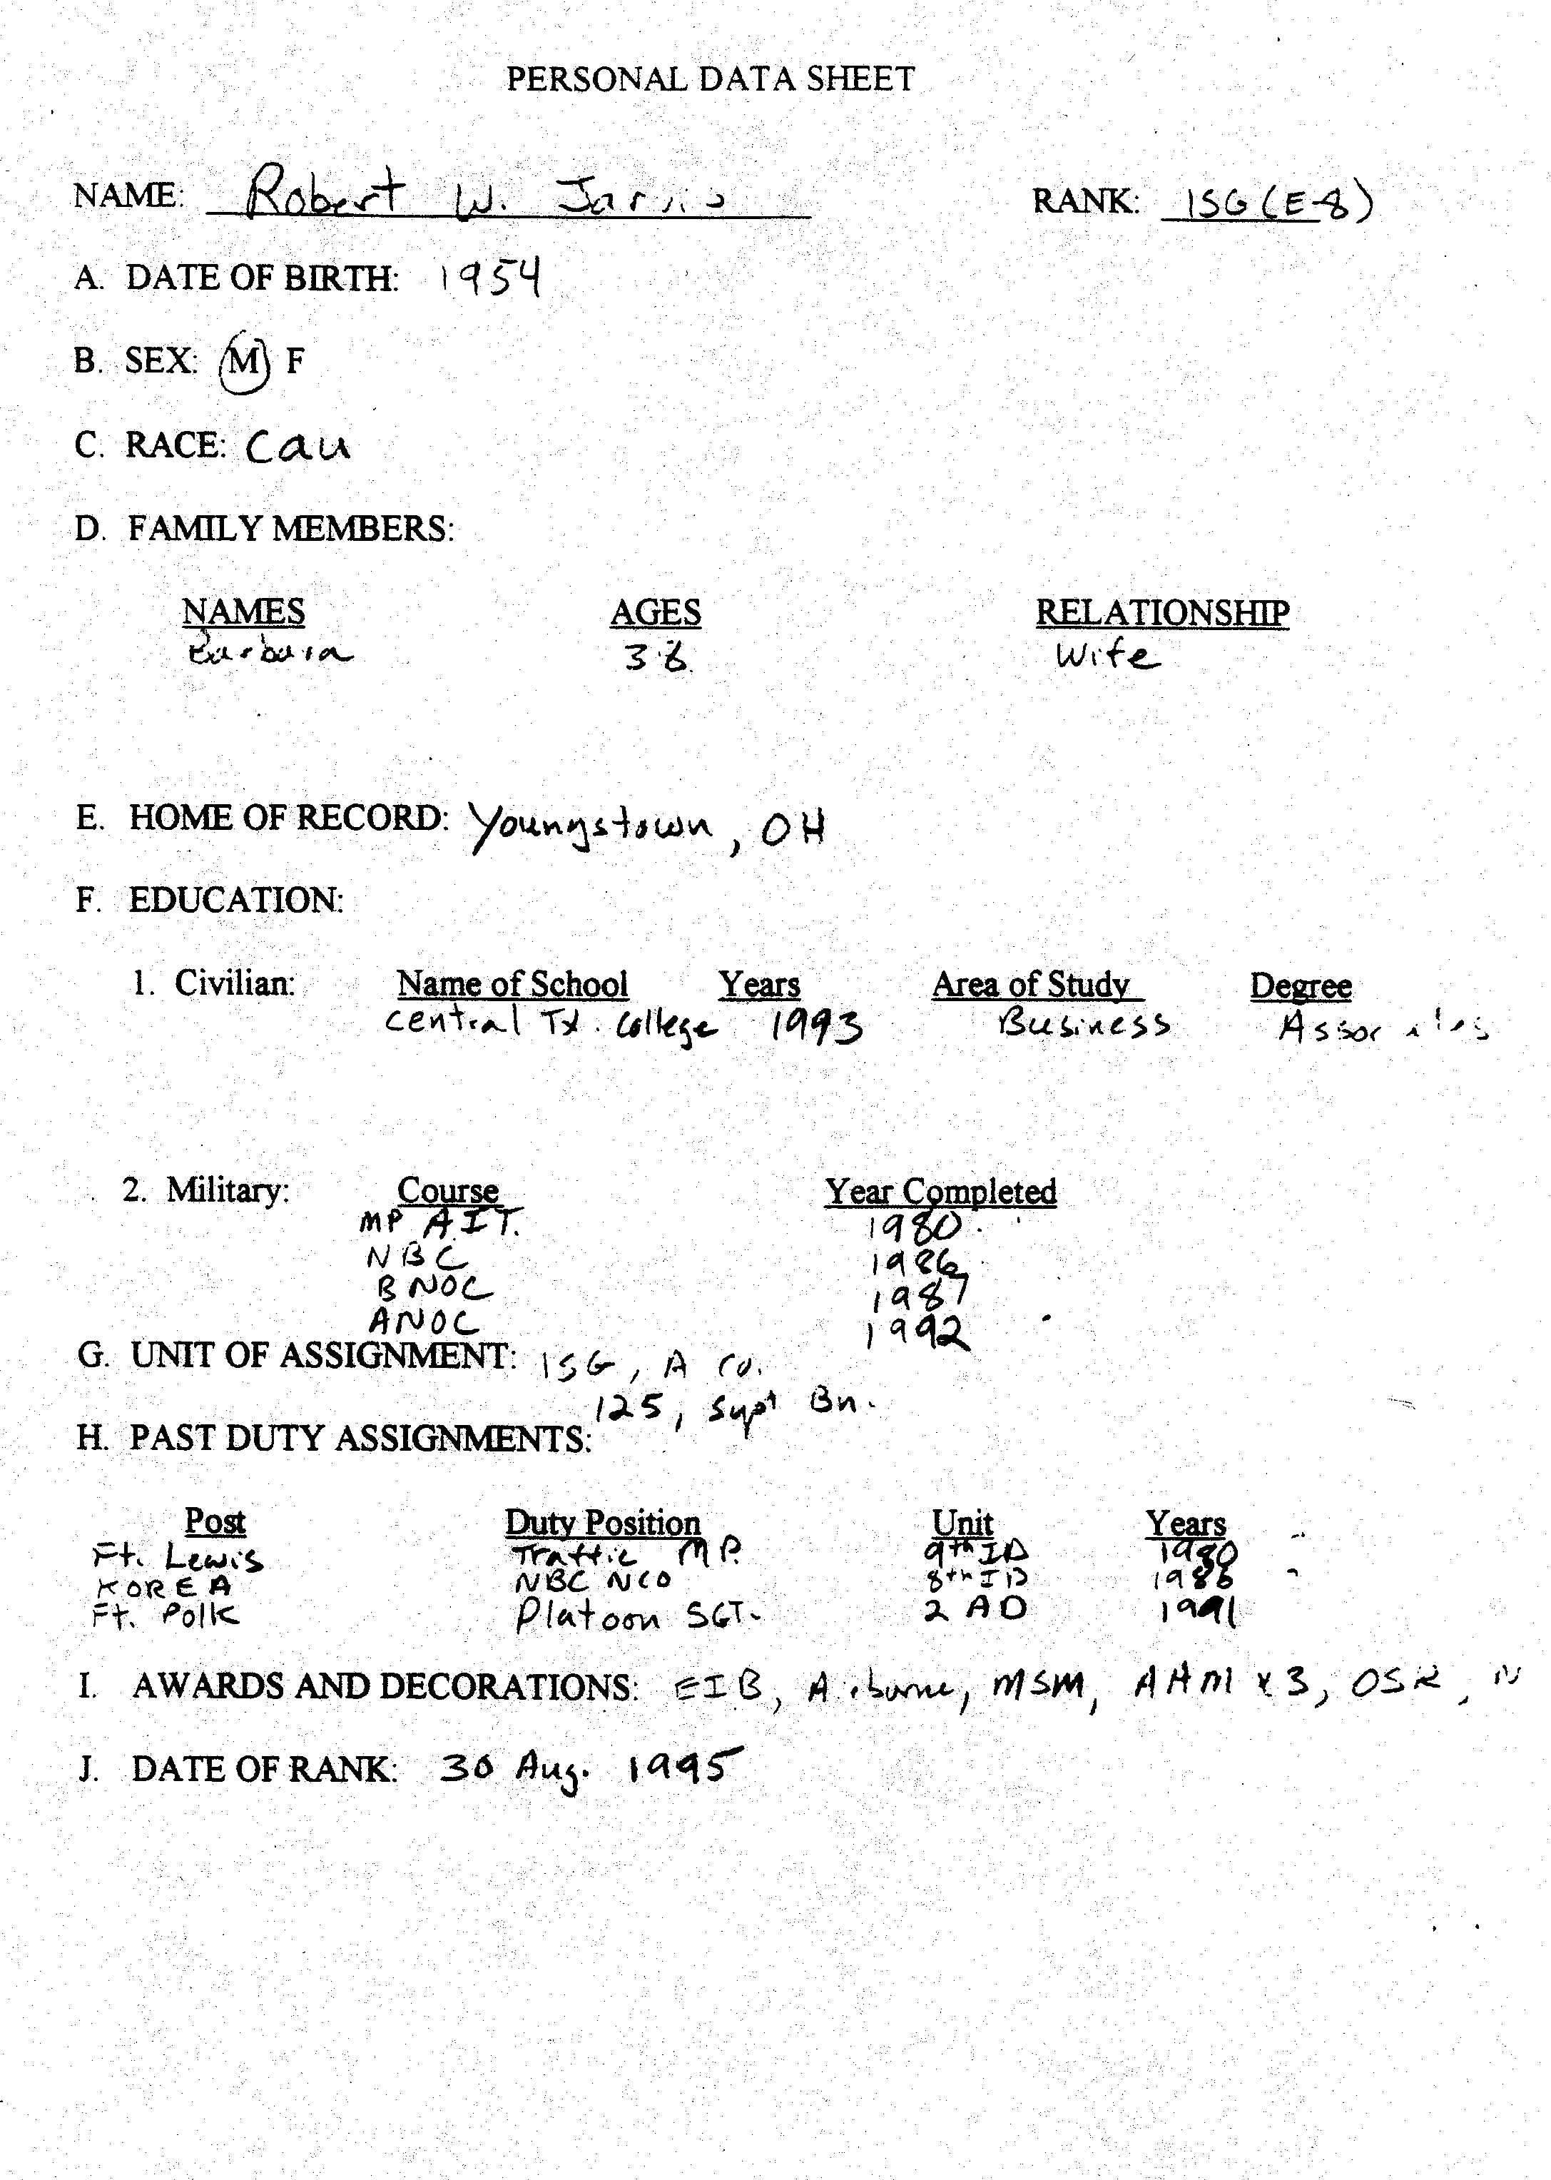
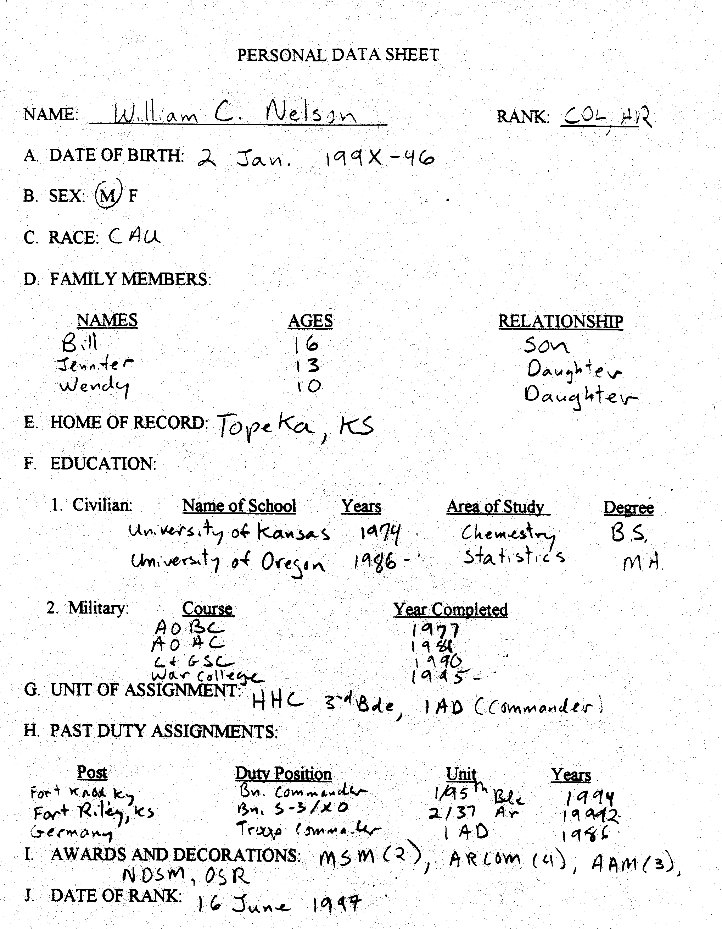
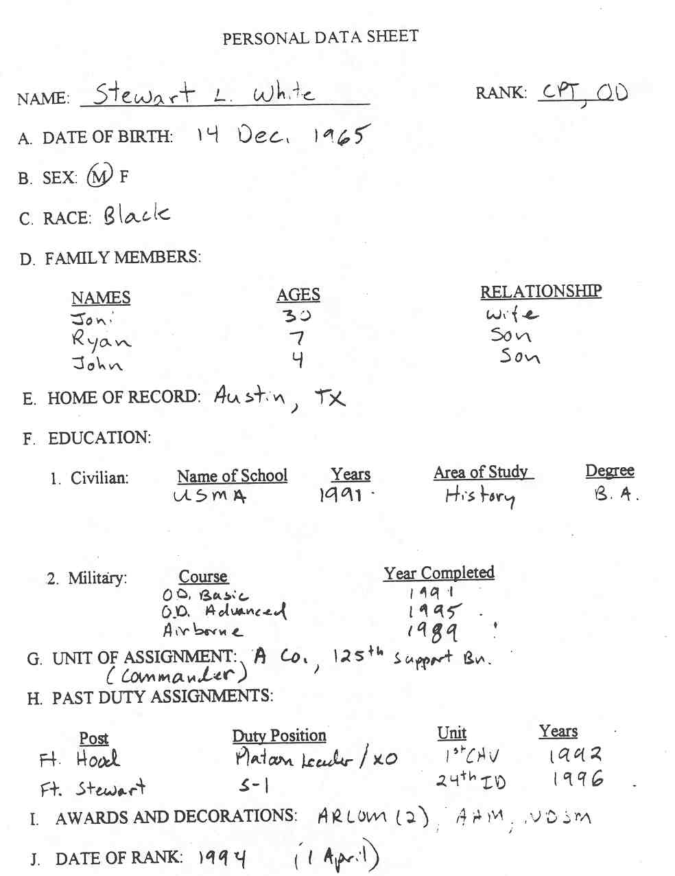
VOIR DIRE
SAMPLE SOLUTION FOR SKILL DRILL #1
MEMBER’S QUESTIONNAIRE
TO PROSPECTIVE JURORS
This questionnaire is designed to obtain information from you with respect to your qualifications to sit as a member in this case. By the use of the questionnaire, the process of member selection will be substantially shortened. Please answer the following questions as completely and truthfully as possible. The information contained within the questionnaire will become part of the court's permanent record, but it will not be distributed to anyone except the attorneys in the case and the military judge. During the questioning by the military judge and the attorneys, you will be given an opportunity to explain or expand any answers, if necessary.
Because this questionnaire is part of the jury selection process, the questions must be answered by you under penalty of perjury and you should fill out this questionnaire by yourself without consulting any other person.
If you wish to make further comments regarding any of your answers, please use the Explanation Sheet at the back of your questionnaire to do so.
If you do not understand a question, please write "I do not understand" and the question will be explained to you in court. Please realize there are no right or wrong answers--just honest ones. You are under oath and must answer truthfully.

1. Name: __________________________________________________________

2. Birthdate: ______________________________

3. Are you: ______ married ______ living with someone ______ divorced
______ separated ______ widowed ______ single

(a) Are any other persons currently residing in your home? _________________________

(b) What is their relationship to you? ___________________________________________

(c) What is their job or occupation? ____________________________________________

4. What is your current duty assignment?

(a) Where do you work? _____________________________________________________

(b) What is your job title? ____________________________________________________

(c) How long have you had this job? ____________________________________________

(d) In your job, do you have authority in supervising others? _______ Yes ______No

(e) Please describe your job responsibilities: ______________________________________

(f) What kind of jobs have you held in the past? ___________________________________

5. If married or sharing a household with someone (other than a child),
is he/she: ______ currently employed ______ student ______ retired
______ unemployed ______ homemaker

IF YOUR SPOUSE, OR INDIVIDUAL YOU ARE RESIDING WITH IS NOT CURRENTLY EMPLOYED, ANSWER THESE QUESTIONS FOR HIS/HER LAST JOB.

(a) Where did he/she work? ___________________________________________________

(b) What was his/her job title? _________________________________________________

(c) How long did he/she have that job? ___________________________________________

(d) In his/her job, did he/she have authority in hiring, firing, or supervising others?
_______ Yes _______ No

(e) Please describe his/her job responsibilities:
________________________________________________________________________

(f) If unemployed, what is his/her source of income? ________________________________
________________________________________________________________________

(g) What jobs has he/she held in the past? _________________________________________
________________________________________________________________________

6. What was the last grade you completed in school? __________________________________

7. If you attended college, vocational, or technical school what was your:

(a) Major subject? ____________________________________________________________

(b) Name and location of school? _______________________________________________

(c) What degrees, if any do you hold? ____________________________________________

(d) What do you consider your most important or meaningful informal learning experience? ______________________________________________________________________________________________________________________________________________________

8. If your spouse or the person with whom you share your household attended college, vocational, or technical school, what was his/her:

(a) Major subject? ____________________________________________________________

(b) Name and location of school? _______________________________________________

(c) What degrees, if any, does he/she hold? ________________________________________

9. Since leaving school, have you attended classes, trade schools, correspondence courses, seminars, or workshops (include service schools)? _______ Yes _______ No. If yes, briefly describe: _____________________________________________________________________

10. Is any member of your family currently serving in any branch of the armed forces of the United States of America? (Including the military reserves or ROTC.)
_______ Yes _______ No.

11. Has any member of your family ever been in any branch of the armed forces?
_______ Yes _______ No

12. Have you, any member of your family, or any of your friends ever received a security clearance? _______ Yes _______ No

Ever been denied a security clearance? _______ Yes _______ No

13. What is your religious affiliation, if any? ________________________________________

How often do you attend services?

(a) more than once a week (d) occasionally

(b) every week (e) rarely

(c) frequently (f) never

Have you ever had a different religious affiliation?
_______ Yes _______ No

If yes, what religion? ______________________________________________________

14. What activities, if any, other than attendance, are you involved in with your church, temple, or religious organization? ____________

15. Are you presently or have you ever been a member of any societies, unions, professional associations, civic clubs, fraternities, sororities, or other organizations or groups?
_______ Yes _______ No If yes, which ones?
________________________________________________________________________

(a) Have you served as an officer for any group or organization?
________________________________________________________________________

(b) If yes, what group(s) or organization(s) and what position(s)?
_______________________________________________________________________

16. What are your hobbies, favorite recreations, pastimes, and spare time activities?
_______________________________________________________________________

17. Do you have children or other dependents living in your home?
_______ Yes _______ No

18. Do (did) your children attend a public or private school? ____________________________

19. Please provide us with the following information on your children, step-children, and/or grandchildren;

NAME AGE EDUCATION OCCUPATION
_
_
_
_
_

20. Please provide the following information on your parents (step-parents), brothers (step-brothers), and sisters (step-sisters):

NAME AGE EDUCATION OCCUPATION
_
_
_
_
_

21. Are you (or were you) employed by, or connected with, a law enforcement agency? (This includes police, sheriff, FBI, CIA, IRS, U.S. Marshal, Highway Patrol, Drug Enforcement Administration, State Attorney, State Prisons or County Jails, Attorney General, Family Services, United States Attorney, Immigration and Naturalization
Service, Probation Office, or any other agency). _______ Yes _______ No

If yes, what agencies? ___________________________________________________________________________

22. Do you have any friends or relatives who are (or were) employed by, or connected with, a law enforcement agency? (This includes police, sheriff, FBI, CIA, IRS, Highway Patrol, Drug Enforcement Administration, State Attorney, State Prisons or County Jails, Attorney General, Family Services, United States Attorney, Immigration and Naturalization Service, Probation Office, or any other agency). _______ Yes _______ No

If yes, what agencies? _________________________________________________________

23. Have you, any family member, or friends ever been a member of an auxiliary or police reserve unit such as an auxiliary deputy sheriff or constable? _______ Yes _______ No

24. Have you, any family member, or friends ever served as a military policeman?
_______ Yes _______ No

25. Have you, any family member, or friends ever applied for a job in law enforcement?
_______ Yes _______ No

26. Have you, any family member, or friends ever worked as a secretary, clerk, filing assistant, dispatcher, or back-up employee of any law enforcement agency?
_______ Yes _______ No

27. Have you, any family member, or friends ever worked in a courthouse or been a court watcher? _______ Yes _______ No

28. Have you, any family member, or friends ever worked in a prison, jail, or detention center of any sort? _______ Yes _______ No

- Have you, any family member, or friends ever worked in a security or detective service?
_______ Yes _______ No

30. Have you, any family member, or friends ever worked with or worked for any State Attorney's Office, United States Attorney's Office, Attorney General's Office, or any other city, county, state, or federal attorney's office? _______ Yes _______ No
If yes, please explain:
___________________________________________________________________________

31. Have you, any family member, or friends ever used the services of any state or District Attorney's Office or U.S. Attorney's Office? _______ Yes _______ No
If yes, please explain:
____________________________________________________________________________

32. Have you ever attended any course, seminar, lecture, or demonstration connected with any law enforcement agency? _______ Yes _______ No

(a) Do you belong to, or associate with, any groups that have crime prevention or law enforcement as a goal? _______ Yes _______ No If yes, which groups?
___________________________________________________________________________

33. Have you, any family member, or friends ever volunteered your services to any law enforcement agency? _______ Yes _______ No

34. Do you know any lawyers, district attorneys, or judges? _______ Yes _______ No

(a) Who? __________________________________________________________________

(b) Have you ever hired a lawyer for any reason?
_______ Yes _______ No

(c) What was the reason(s) for hiring a lawyer?
__________________________________________________________________________

(d) Have you ever had a bad experience with a lawyer? _______ Yes _______ No
Please explain: ______________________________________________________

(e) How do you know a judge? ________________________________________________

(f) How do you know a prosecutor? ____________________________________________

(g) How do you know a lawyer? _______________________________________________

35. Have you ever received any training in law? _______ Yes _______ No

36. Have you or anyone you know ever worked in any law office or agency that dealt with the law? _______ Yes _______ No
If yes, describe: ______________________________________________________________

37. Have you, any family members, or friends ever filed a police report?
______ Yes _______ No
If yes, please explain: _________________________________________________________

38. Have you, any family member, or friends ever called the police?
______ Yes _______ No
If yes, please explain: _________________________________________________________

39. Have you, any family member, or friends ever been interviewed by the police or any other law enforcement agency? _______ Yes _______ No
If yes, why were you/they interviewed? ___________________________________________

40. Have you, any family member, or friends ever had a pleasant experience involving law enforcement? _______ Yes _______ No
If yes, please explain: _________________________________________________________

41. Have you ever had an unpleasant experience involving law enforcement?
_______ Yes _______ No
If yes, please explain: ______________________________________________________

42. What criminal cases have you followed in the media? ______________________________

(a) Why did you follow the case(s)? ____________________________________________

43. Have you, any family member, or friends ever been the victim of physical or domestic violence? _______ Yes _______ No If yes, please tell us about that:
___________________________________________________________________________
___________________________________________________________________________

44. Have you, any family member, or friends ever been a victim of any crime?
_______ Yes _______ No
If yes, where, when, and what type of crime?
___________________________________________________________________________

45. If you, a family member, or friend have been a victim of any crime, was anyone charged with the offense? _______ Yes _______ No
If yes, was that person prosecuted in court and what was the result?
___________________________________________________________________________

46. Have you, any family member, or friends ever been a witness in a criminal case?
_____ Yes _____ No
If yes, what was the nature of the case? _______________________________________

47. Have you, any family member, or friends ever been a witness in a civil case or any other legal hearing? _______ Yes _______ No

48. Have you, any family member, or friends ever sued someone or wanted to sue someone?
_______ Yes _______ No
If yes, please describe: _____________________________________________________
________________________________________________________________________

49. Has anyone ever sued you or a family member? _______ Yes _______ No
If yes, please describe: ________________________________________________________

What was the nature of the case? ________________________________________________

- Have you, any family member, or friends ever been charged, arrested, indicted, or convicted of any criminal offense? _____ Yes _____ No If yes, please explain:

51. Have you ever served as a juror before? _______ Yes _______ No
If yes, how many times? _______

(a) For each time you have served, please list the type of case and dates:

(b) If yes, how did you feel about that (those) experience(s)?

(c) Were you ever the foreman or forewoman of the jury? _______ Yes _______ No

(d) Could you reach a verdict? _______ If not, describe:

(e) What did you like or dislike about your prior jury service?

52. Regarding your jury service: (circle the letter(s), which apply to you)

(a) I can tell pretty easily when a person is telling a lie.

(b) When I make up my mind I rarely change it.

(c) I am easily influenced by the opinion of others.

(d) I always follow my own ideas rather than do what others expect of me.

(e) Please describe what the experience was like for you personally:

53. Have you ever served on a Grand Jury? _____ Yes _____ No
If yes, please give dates and details:

54. Have you ever appeared before a Grand Jury? _______ Yes _______ No

55. Have you ever been to court before? _______ Yes _______ No

If yes, under what circumstances?

56. Have you or anyone you know ever testified in court? _______ Yes _______ No

If yes, please describe:

57. In your opinion, what are the three (3) most important problems with the law today?

No. 1: __________________________________________________________________

No. 2: __________________________________________________________________

No. 3: __________________________________________________________________

58. What is the main problem in our society today?
__________________________________________________________________________

59. Have you or any member of your family ever belonged to, or contributed money or time to, any neighborhood watch, crime stoppers, victims for victims, mothers against drunk drivers, students against drunk drivers, or other related programs?
_______ Yes _______ No
If yes, which group(s)? ____________________________________________________

- Would you characterize yourself as a leader or follower? ____________________________

- If you were in a group of people that you did not know very well, would you be labeled as a leader or follower? __________________________________________________________

62. Have you ever studied psychiatry, psychology, sociology, or any related subjects?
_____ Yes ______ No
If yes, please describe: _____________________________________________________

63. Have you, any family member, or friends ever studied or read about psychology, sociology, or psychiatry? _______ Yes _______ No

If yes, please describe: ________________________________________________________

64. Have you, any family member, or friends ever studied or read about medicine, chemistry, biology, engineering, pharmacology, toxicology, or any related subjects?
_____ Yes _____ No
If yes, please explain: ______________________________________________________

65. Do you think some people exaggerate their problems in order to gain the sympathy of others? _______ Yes _______ No
Please explain: ___________________________________________________________

66. Have you, any family member, or friends ever worked or volunteered your services at any rape crisis center, alcohol or drug rehabilitation program, suicide prevention center, battered women and children center, crisis hot line, or any related group?
_______ Yes _______ No
If yes, please describe: _____________________________________________________

67. Have you, any family member, or friends ever used any of the above services?
______ Yes ______ No
If yes, please explain: ______________________________________________________

- Have you, any family member, or friends ever had an unwanted sexual contact?
_______ Yes _______ No
If yes, please explain: (DO NOT GIVE NAMES): ________________________________________________________________________

69. How do you feel about the use of alcohol in our society? ____________________________

70. Do you personally know anyone whom you believe has a drinking problem or is addicted to medication? _______ Yes _______ No
If yes, please explain: (DO NOT GIVE NAMES):

71. In your opinion, what is the number one problem in America today?
________________________________________________________________________

72. In your opinion, what is the principal cause of crime in America?
________________________________________________________________________

- Have you ever witnessed any violence (other than on TV)? _______ Yes ______ No
Please explain:

74. Have you personally felt fearful of being victimized by violent crime or been fearful those members of your family would be victimized? _____ Yes _____ No
If yes, describe those fears: _________________________________________________
________________________________________________________________________

75. What steps do you think people who are frightened about crime should take to protect themselves? ___________________________________________________________________

- What steps have you taken to protect yourself? ______

- What in your opinion should or could be done about the crime problem? _____

- What is the first thing that comes to your mind when you think of:
(a) Defense Attorneys: _______________________________________________________
(b) Prosecutors: _____________________________________________________________

79. Is there anything else we should know about you?

80. Is there anything you would like to discuss privately with the court?
_______ Yes _______ No

If yes, please explain: ______________________________________________________

Signature
Date

VOIR DIRE
SAMPLE SOLUTION FOR DRILLS 2-4
TRIAL COUNSEL
[Note: After the members respond to each question asked, counsel must accurately state for the record their responses, e.g., “affirmative response by all the members.” The following sample solution is not a comprehensive list of all the questions counsel may want to ask during voir dire. Rather, it offers an example of questions relating to the legal issues raised in the fact scenario.]
CONSPIRACY ISSUES
- Members, I would like to focus on conspiracy. The military judge will instruct you that a conspiracy is a two-part crime. First, there must be an agreement to commit a crime; and second, there must be some activity to carry out this agreement. Do you all agree that in its simplest form a conspiracy involves an agreement between at least two people to commit a criminal act?

- Let’s focus on the first part—the agreement. The military judge will instruct you that the agreement in a conspiracy does not have to be in any particular form. Do you all agree that the agreement could be oral?

- Do you all agree that the agreement could be based upon actions?

- Do you all agree that the agreement could simply be a meeting of the minds without any words?

- Do you all understand that while the agreement continues, the accused or a co-conspirator must do something in order to accomplish the criminal act intended?

- For example, two people agree to rob a liquor store, and one of them goes out and buys a gun to use in the robbery. Do you all agree that at this point, even before the actual robbery takes place, the two may be guilty of conspiracy?

- The military judge will further instruct you that a conspiracy is a crime separate from the underlying offense. In the robbery example, if the two people actually did go through with the planned robbery, they may be guilty of both conspiracy and robbery. Does everyone understand this principle of law?

- Please look at the flyer before you. Charged are the offenses of rape, kidnapping, conspiracy to commit rape, and conspiracy to commit kidnapping. Do you all agree that rape and conspiracy to commit rape are two separate offenses?

- Do you all agree that kidnapping and conspiracy to commit kidnapping are two separate offenses?
- In this case, if you find, beyond a reasonable doubt, that the accused is guilty of conspiracy to commit rape, can you convict him of that offense separate from the rape offense?

- In this case, if you find, beyond a reasonable doubt, that the accused is guilty of conspiracy to commit kidnapping can you convict him of that offense separate from the kidnapping offense?

- Do you all understand the difference between a carefully planned crime and a crime of impulse?

- If you find the accused guilty of the conspiracy charges, will you consider that fact in reaching an appropriate sentence?
ACCOMPLICE TESTIMONY ISSUES
- Do you agree that the government has no control of who witnesses a crime?

- Do you agree that the government must use the witnesses who have the most information in order to get to the truth?

- In a conspiracy case, would you agree that often the only evidence of the conspiracy is likely to come from co-conspirators?

- COL X, do agree that when individuals plan a crime they are likely to do it in secret?

- Would any of you not believe the testimony of an accomplice simply because he was also involved in the crime?

- Would you all agree then that an accomplice could be a truthful witness?

- If the government presents evidence that supports the accomplices’ testimony, will that make you more likely to believe it?

- In this case, the government will present the testimony of two accomplices, PFC Williams and PFC Smith. If you find their testimony credible, could you consider their testimony in reaching a verdict in this case?

- Do you all agree that when an accomplice testifies, he may not only implicate the accused, but he may also incriminate himself?

- Major A, would you agree that we all have a constitutional right against self-incrimination—that is, the right to remain silent when questioned about criminal activity?

- In order to protect the accomplices’ constitutional rights against self-incrimination, the government can provide some protection. A type of protection the government can provide is called testimonial immunity. Has anyone heard of this term before?

- Do you understand that the government can’t use a witness’s immunized testimony against him?

- Does everyone understand that the witness with immunity may still face prosecution for his role in the crimes based on other evidence?

- Does everyone understand that if the immunized witness lies on the stand, he can also be prosecuted for perjury?

- Would any of you not believe the testimony of a witness simply because the government gave him immunity?

- In this case, the government gave immunity to PFC Williams and PFC Smith. If you find their testimony credible, could you rely on it in reaching a verdict in this case?
PRIOR INCONSISTENT STATEMENT ISSUES
- CPT C, I noticed from your questionnaire that you have two children, ages 4 and 7, is that correct?

- Have you ever disciplined your children?

- When you’ve confronted your children with something they did wrong, say getting into the chocolate chip cookies, do they always immediately confess to their wrongdoing?

- On some occasions have they initially denied they did anything wrong and only confessed after being confronted with overwhelming evidence, such as the chocolate on their hands and face?

- Does everyone agree that this is human nature?

- Would you all agree that sometimes adults also deny wrongdoing when first confronted?

- Would you all agree that some people only admit to their wrongs after being confronted with strong evidence?

- Would you all agree that this does not automatically make the final confession untruthful?

- Would you all agree that in fact the confession might be truthful because the person realizes that he can not lie his way out of trouble any longer?
VOIR DIRE
SAMPLE SOLUTION FOR DRILLS 2-4
DEFENSE COUNSEL
[Note: after the members respond to each question asked, counsel must accurately state for the record their responses, e.g., “affirmative response by all the members.” The following sample solution is not a comprehensive list of all the questions counsel may want to ask during voir dire. Rather, it offers an example of questions relating to the legal issues raised in the fact scenario.]

Immunity Issues
- Do you all believe that everyone who swears to tell the truth actually tells the truth?

- I expect that some witnesses will testify about PFC Williams' and PFC Smith's poor character for truth and veracity. Will you agree to take this testimony into consideration in determining whether or not to believe these witnesses? (Consider asking the military judge to give preliminary instruction on witness credibility at this point).

- 1SG Y, do you agree that a witness charged with the same crimes as the accused, may have a motive to lie in order to protect himself?

- For example, do you agree that a witness may feel that if he testifies in a manner that is favorable to the government, then the government may give him leniency in his case?

- CPT C, do you agree that a witness who has a plea agreement with the government may also have a motive to lie?

- Wouldn't you all agree that in order to get the benefit of a plea agreement, a witness must testify the way the government wants him to?

- MAJ A, do you agree that a witness who has a deal with the government has a strong incentive to testify the way the government wants in order to keep the deal?

- Do all members agree with MAJ A?

- Do you all agree that witnesses who are best friends are likely to protect each other so they won’t get in trouble?

- In evaluating a witness’s testimony, would you consider all of these and any other potential motives to lie?

- COL X, who is less believable, a person that has one motive to lie or a person that has four motives to lie?

- MAJ A, what is your opinion?

- How about you, CPT C?

Accomplice issues

- Do you agree that the mere presence at the scene of a crime does not establish guilt?

- Do you agree that the government has the burden to prove each and every element of every offense?

- The military judge is going to instruct you that when someone withdraws from a crime, that is, decides not to participate in a crime and makes it known to others, he is not liable for any offenses committed after he withdraws from the crime?

- Do any of you disagree with this principle of law?

- If the military judge instructs you that the testimony of an accomplice, another person who is a party to the crime, is of questionable integrity and is to be considered with great caution, will you consider this instruction in evaluating the accomplice's testimony?

- COL X, why do you think an accomplice’s testimony might be of questionable integrity?

- Do all the members agree with COL X?

- Do all members agree that an accomplice's greatest motive to lie about another individual's involvement in the crime might be to save himself, or minimize his own involvement?

- How many of you believe that an accomplice's testimony could be less reliable than a witness who was not involved in the crime?

- Do you all agree that it is not the number of witnesses that the government calls to testify, but the quality of their testimony that is important in deciding what the truth is?

- Will you consider any self-serving motives a witness might have that would effect the reliability and truthfulness of his story?

Prior Inconsistent Statement Issues

- If there were conflicting testimony in this case by the prosecution’s witnesses, would you take this into consideration on the question of reasonable doubt?

- What would you think about the reliability of a co-accused's testimony if he gave two completely different statements to the police?

- Would you take extra care in evaluating his statements and testimony?

- Would you all agree that co-accused, who attempt to minimize their own involvement by lying to the police, could also be lying to you?

Q How many of you would be less inclined to believe the co-accused if he gave two completely different statements to the police?

VOIR DIRE
SAMPLE SOLUTION FOR SKILL DRILLS 5-6
SAMPLE USE OF CLOSED ENDED QUESTIONS
FOR A CHALLENGE FOR CAUSE
Q Captain X isn’t it true you believe SPC Jones is guilty of something or else she wouldn't be here?

Q In fact, at this moment you believe she is guilty, don’t you?

Q You would agree with me that once you form an opinion about something, it's difficult, if not impossible, to set that opinion aside, isn’t it?

Q Even though you agree that the law says a person is presumed innocent until proven guilty, based on the publicity in this case you've already formed some feeling or opinion that SPC Jones is probably guilty, isn't that so?

Q Wouldn't you also agree with me that there isn't anything that the trial counsel or the military judge can say that would change your mind?

Q Wouldn't you also agree with me that the opinion you formed about the guilt or innocence of SPC Jones would affect your deliberations as a member in this case?

Q Wouldn’t you also agree that although you could be a good juror in any other case, but for the pretrial publicity in this case, you might not be as fair as you would like to be in this particular case?
SAMPLE VOIR DIRE CHECKLIST

Counsel should consider the following areas in deciding what questions to ask prospective panel members in any case. The military judge will likely ask some of these questions but follow-up may be necessary. The checklist and sample questions are not an exhaustive list and must be tailored to the facts of an individual case. (* Indicates questions for individual voir dire).

LAW:

General:

After having read the flyer, is there anything about this case that would prevent you from being fair and impartial?

Can you set aside sympathy, bias, and prejudice in reaching a just verdict?

Will you wait until you receive all the evidence and the military judge’s instructions before making up your mind?

Will you follow the law as the judge instructs you, even if you disagree?

Reasonable Doubt and Burden of Proof:

Defense Counsel:

Do you all understand and agree that my client stands before you today innocent of any charges?

If you had to vote on my client’s guilt or innocence right now, how would you vote?

Member X can you apply the presumption of innocence in this case?

Can every member apply the presumption of innocence in this case?

Do you all agree that before you can convict my client you must find him guilty of every element of the offense beyond a reasonable doubt?

Member X, do you think the government has a fair burden?

Member Y, can you promise to hold the government to this burden?

After hearing all the evidence in this case, if there is a reasonable doubt as to the guilt of my client, are you willing to vote for a finding of Not Guilty?

Trial Counsel:

Would you all agree that proof beyond a reasonable doubt does not mean proof beyond any doubt?

Do you understand that the burden of proof is the same whether this is a rape case or an AWOL case?

Member X, if the defense were to suggest an explanation of innocence that you found incredible, do you understand the government is not required to disprove this theory?

II. CASE ON TRIAL:

Knowledge of the Parties:

Do any of you know the Judge?

Do any of you know the trial counsel?

Do any of you know the defense counsel?

Do any of you know the accused in this case?

*Describe the nature of your relationship.

*Have you ever received legal advice from the trial counsel in the past?

*Have you always followed the trial counsel’s recommendations?

*Because of this past relationship, would you be more receptive to the trial counsel’s evidence or arguments?

Knowledge of the Witnesses:

Does anyone know witness X?

*How do you know her?

*Are you more likely to believe his or her testimony because of past dealings?

Knowledge of the Case:

Have any of you read or heard anything about this case prior to today?

*Member X, what have you heard or read?

*Do you consider these news reports, blotter reports, police reports, an accurate statement of the facts?

*Have you formed an opinion based upon the information you have received?

*Do you agree that you must decide the accused’s guilt or innocence based solely on the facts that are presented in this trial?

EXPERIENCE OF PANEL MEMBERS:

Prior Court Duty:

Have any members sat on a court-martial before?

How many times?

How long ago?

Do you recall what the case was about?

Do you recall what the defense was?

Did the accused testify in that case? (Defense Question)

Did it bother you that the accused elected not to testify? (Defense Question)

What was the outcome of the case?

Can you separate these past experiences and judge this accused based solely on the evidence presented?

Victim of Crime:

Have any of you or a close family member or friend been the victim of a crime similar to the crime charged here?

*Please explain the experience.

*Was this a traumatic experience?

*Was the perpetrator caught?

*Does it bother you that the perpetrator has never been brought to justice?

*Did you participate in or view the trial?

*What did you think about the prosecutor?

*What did you think about the defense counsel?

*Were you satisfied with the job law enforcement did?

*Were you satisfied with the outcome of the case?

*How will that experience affect your ability to sit on this case?

Experience with Law Enforcement:

Have any of you or members of your family served in a law enforcement capacity?

*Did the family member/friend ever discuss his/her work with you?

*Did you ever hear him/her discuss cases involving rape, robbery, etc.?

*Have any of you had close dealings with law enforcement in the past?

*Were you satisfied with this experience?

*Will you give special consideration to law enforcement witnesses simply because of their status?

Crime Committed While Commander/Supervisor:

Has a soldier working with/for you ever been court-martialed?

Please describe.

What level of court-martial?

What were the crimes charged?

Did you recommend court-martial?

What level?

What was the outcome of the case?

Were you satisfied? Why or why not?

Did you testify for or against the soldier?

Was this testimony during findings or at sentencing?

BIAS:

Alcohol Bias:

Please raise your hand if you drink acohol.

How do you feel about someone who drinks alcohol?

Are you less likely to believe the accused/victim/witness simply because he drinks alcohol or was drinking on the day in question?

How would you evaluate the victim/witness/accused testimony if you found out that he had been drinking on the night of the incident?

Drug Bias:

Do you know anyone with a drug problem?

Are you less likely to believe the accused/victim/witness because he uses drugs or used drugs on the day in question?

Do you have a drug problem in your unit?

How often do you test for drugs in your unit?

How do you feel about the Army urinalysis program?

Is it reliable?

Are you aware of any cases involving a false positive?

Are you aware of any urinalysis testes where there were problems with the chain of custody?

Status of Witness. Do you think the testimony of a police officer, commander, expert is more/less credible simply because of their status?

Bias Against the Accused: (Defense Counsel Questions)

What would you think about the accused if he doesn’t testify?

Would you assume that he has something to hide if he doesn’t testify?

Is a soldier who has a good/bad service history more/less likely to have committed the offenses charged?

If an accused pleads guilty to one charge, is he more likely to have committed the other charged offenses?

Can you tell a criminal just by looking at him?

Bias for the Accused:

Do any of you go to the same church/club as the accused?

Will that affect your ability to sit on this case?

Are you more/less likely to give the accused favorable consideration because you go to the same church or share the same faith?

Credibility:

Victim/Witness Testimony Presentation:

Have any of you ever made a speech to a group of strangers?

Have you ever had to discuss personal issues/problems in front of a group of strangers?

How did it make you feel?

Do you all agree that it can be a very uncomfortable experience?

Can you consider the nervousness and embarrassment of the victim/witness in judging their credibility?

Can you appreciate that a person may be nervous and be telling the truth?

Witness Motive/Bias:

Do you believe that a witness/victim may have one or several motives to lie?

Would you consider a witness’s personal interest in the case in evaluating the witness’s credibility?

Do you believe that children are more/less likely to lie than adults?

What do you think of a victim who only reports a crime after a motive to lie arises?

Eyewitness:

Defense Questions:

Do you agree that lighting/distance/opportunity to view/fright/etc. can affect a witness’s ability to accurately see and report an incident?

Do you think you would be better able to describe someone of your own race?

Trial Counsel Questions:

Do you think it is possible for a witness to give an accurate description even in a fast moving situation?

Would you all agree that different people can see the same incident differently?

Would you expect the victim of a rape/assault to always give a detailed description of the suspect?

Can you still believe a witness who can only give a partial description of the suspect/incident?

SUPERIOR/SUBORDINATE RELATIONSHIPS:

Defense Counsel Questions:

How long has he/she worked for you?

* Do you respect your superior/subordinate’s opinion?

* Have you received an OER/NCOER from him/her?

* Are you due an OER/NCOER from him/her?

* When?

* How often do you see each other?

* Do you socialize with him/her?

* Do you discuss leadership/command/punishment philosophy?

* Have you ever sought their advice on a disciplinary issue?

*Please explain.

Trial Counsel Questions:

Does your superior expect you to speak freely with him/her?

*What is the most significant disagreement you have ever had with him/her?

*How did you resolve it?

*Does he/she allow for honest discussion and disagreement?

*Are you reluctant to speak your mind to him/her?

*Would you feel any pressure to adopt his opinions simply because he/she is your superior?

*What do you expect of subordinates if they disagree with you?

*Do you seek honest feedback from your subordinates?

*What do you do if you disagree with his/her ideas/opinions?

*If your subordinate were to disagree with you over any issue in this case, would you have a problem with that?

SENTENCING QUESTIONS:

Defense Questions:

If you find the accused guilty of a serious crime, could you consider sentencing the accused to no punishment?

If the accused is found guilty, do you understand that you must consider his personal and military record in determining an appropriate sentence?

Would you consider the fact that the victim suffered no permanent physical injuries in determining an appropriate sentence?

Will you consider the interests of the accused and his family in determining an appropriate sentence?

Do you think that rehabilitation is an important function of punishment?

Trial Counsel Questions:

Will you consider any aggravating evidence including the impact on the victim in determining an appropriate sentence?

Do you agree that there is no such thing as a victimless crime?

Do you understand harm to society/military community/Army when someone does X (i.e. writes a bad check)?

Do you think retribution and deterrence are important aspects of punishment?

